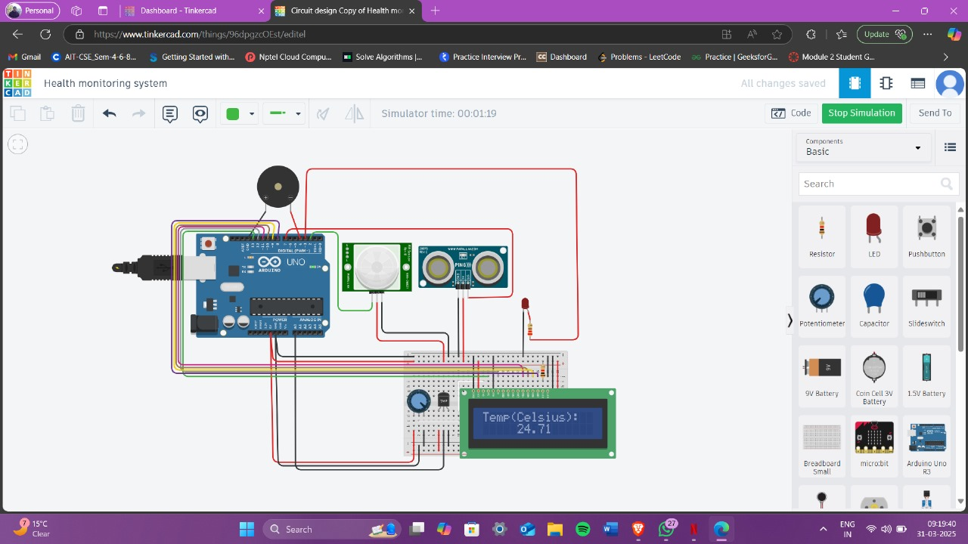

[Circuit design Health monitoring system - Tinkercad](https://www.tinkercad.com/things/96dpgzcOEst/editel?sharecode=vXCzkdLGdjgvMHRu5ZtBIFX_vnF9hb_jvVYAzUtHXbE)